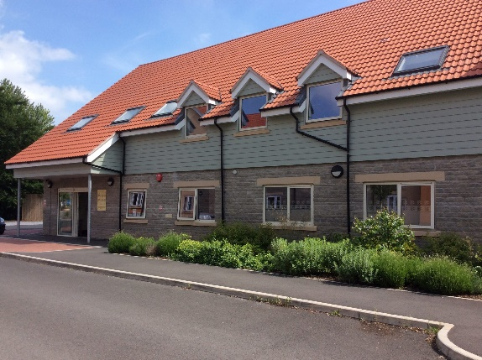
Buttercross Health Centre
CLOSED FOR STAFF TRAINING

Please be aware that the surgery will be closed for staff training from 1pm until 6:30pm on
Wednesday 16th August
During this time, we will be available for urgent queries only, via telephone. The surgery will resume service as normal from Thursday 17th August.
AskMyGP will open from 7:30am and phonelines at 8:30am as normal.

If you require medical attention during this time, please contact 111, or for life threatening illness or injuries, please call 999 or attend your local A&E Department.

We apologise for any inconvenience this may cause and thank you for your co-operation.

